**G**AME **A**NAL**Y**SIS

**Analysis of the game Trine**

**Course**

DZC12 - Design for Games and Play I

**Team Alpha**

Twan van Schijndel (0857767)

Kevin Cleijne (0779007)

Guus van der Weerd (0746371)

Joep Klein Teeselink (0816396)

Jeroen van Hoof (0778486)

**1-3. Introduction**

The game of our choice is the puzzle platform game Trine. Trine is a physics-based action game. Three characters allow clever solutions to challenges created by hazardous puzzles and threatening enemies.

**4. Elements that constitute the game**

You play as a group of three adventurers that landed in a fairytale: a wizard, a warrior and a thief. All characters have their own abilities and ways to interact with objects. The goal is to use these abilities in a creative way to move forward in the game. You can influence the environment to your benefit. For example, you can move boxes, cut ropes or destroy blockades with a hammer. If a character dies, you have to continue with your other players until you reach the next checkpoint, where they will be revived. If all characters are dead, you will be transferred back to the previous checkpoint.

Sometimes combat is needed to overcome obstacles, and sometimes you have to solve some kind of puzzle. The game remains surprising by offering new and creative puzzles and elements.

There is a progression based system where you collect experience items (flasks placed around in the game) which give you new skills once you have collected enough of them, such as bigger boxes or longer planks to summon, multiple arrow to shoot and a throwing ability for the knights hammer.

The storyline provides the user with an engaging element and a reason to go forward - to see what comes next. Together with the artistic graphics and narration that occurs while playing the game, you always want to see ‘what comes next’.

**5. Why is this game fun?**

The game is basically a set of puzzles which you can solve in various ways. Completing these challenging puzzles give you a sense of accomplishment and the game rewards you with a new environment (sense of exploration), a new puzzle and progression through the story. Once you have completed a set of puzzles you will get some additional narration and the game story progresses. The puzzles get more diverse and difficult/complex every time, giving a nice challenging difficulty curve and versatility.

Throughout the game you encounter collectable experience flasks, which you are inclined to grab such that you can level up and obtain new skills to get stronger. The experience flasks are placed in such a way that you generally cannot just find them along the route but you have to effectively go out of your way, explore, to obtain them, usually you need to solve a mini-puzzle to get to them (move objects around, cut a rope so they fall towards you, etc.)

You learn something new every time a new element is introduced, and it allows you to experiment yourself and do things in different ways. The game is visually appealing, with nice lighting and different scenes.

So, to conclude: feeling good about yourself for solving increasingly difficult puzzles and being rewarded for solving these puzzles and exploring the world is what makes this game fun.

**6. The game as a strictly strategic, mathematical system**

**Collectables**: Bottles of experience points or energy.

**Environment**: Moveable objects, water (breathe), destructible walls, spikes, torches that can be lit with a fire arrow or a swing with the sword, swinging or falling platforms, fire-ball shooting objects, material (determines whether or not the thief can attach its rope to it), checkpoints.

**Enemies**: Can have different weapons, ranged, magic, health, damage modifiers, and intelligence. There are skeletons, bosses, and other types.

**Playable Character: wizard:** Can create and levitate objects, rotate objects, jump medium high and swim underwater.

**Playable Character: thief:** Can sling around the environment using a rope that attaches to certain surfaces. Can fire arrows and use them to break certain objects or kill monsters. Is able to jump the highest and swim underwater.

**d.3) Playable Character: knight**: Can fight using a sword and smash with a hammer to break objects or attack mid-air. Can use his shield (only in combination with sword) to block attacks and stop projectiles. Can jump a short height and walk underwater.

**7. The game as a strictly experiental System**

**a) Objects:** The objects of Trine are the player who plays the game and the AI of the game itself. While playing Trine a lot of interaction find place in the game. This can be from succeeding trials or making progress in the story-line.

**b) Attributes:**

**Player**: the 3 playable characters.

**Environment:** Everything you have interaction with your characters, this can vary from enemies to puzzles.

**c) Internal Relationship:** Environment challenges the player to use the right attributes to solve the problem at hand.

**d) Environment:** Trine’s context of play includes factors like the console or PC you are playing Trine on, the motivation you have to play Trine and the way you play it. This is very subjective and can be interpreted in multiple ways by different players. Some people’s motivation to play will be the challenges and the puzzles while others might find it interesting to complete the story of the game. The way you play Thrine can be with different people together which adds another factor, the relationship you have with those players and the way Thrine influences in this relationship. You could become better friends and get irritated because one player might not be doing his job the way you’d like him/her to.

**8. Similar games**

Games like The Lost Vikings are very similar.

Three playable characters each with special attributes which are required to solve puzzles in the environment, one can run very fast, another has a shield to block attacks and provide a platform for another to jump upon, and a third character has a mechanical arm that can be used to reach high places. The goal of this game is to get the vikings home, hence the name.

Honorable Mention: Thomas was Alone.

Thomas was Alone has similar mechanics like Trine, you can control multiple blocks one at a time which have different attributes such as one can jump higher, another is wider so you can use it as a platform for others, another is tiny and can fit into small places. The game is filled with narrative that gives meaning to what is going on and the individual character blocks. You get attached to the story and blocks since they have been given a meaning in their existence. There are also tricky to obtain collectables, for extra challenge. Your reward for progressing this game is that you encounter more difficult puzzles and the storyline progresses with great narration.

**10. Define the roles that are involved in the design and development of your game. And describe their contribution/responsibilities to the realization of the game.**

The game was developed by Frozenbyte, with a team of 20 people.

**Designer:** created the setting and theme of the game, the script and writing.

**Art Department:** created the assets used in the game.

**Gameplay integration and implementation:** The coders that scripted and ‘made’ the game in the chosen engine (custom made by Frozenbyte). This includes the unique 2.5D viewpoint (2d game with 3d background, visible depth)**.** They also made use of Nvidia’s PhysX engine.

**Sound Designer:** composed and performed all the songs and in-game sound assets.

**Voice Actors:** voiced the different characters and narrator to progress the story and make it interesting.

**11. Now, if you were the creators of the game, what would you change/add in order for it to be even more appealing? Redesign one quality of the game in each of the following categories and explain its fundamental difference to the original version.**

**a. Objects**

More pickups such as a strength power up. This would allow for more hectic combat since we could now throw more enemies at you - in order to survive the player needs to platform/move his way to the power up.

Also more variation in enemies would be a welcome change. Enemies are too limited right now, and it would be fun to add some stronger enemies, at least different than skeletons all the time. Maybe some more underwater enemies

**b. Attributes**

Visual Character Customization - different clothes and armor with stats for the warrior/thief/wizard that increase the duration or otherwise modifies an ability they possess. As well as giving them an unique look

**c. Internal Relationships**

More interactions between the different characters in terms of story and abilities. Wizard picking up arrow from the air that the thief shot? Or we give one character a spade so it can dig up hidden treasures. Interaction with different background items in the environment which allows for more hidden treasures and secrets.

**d. Environment**

Removing some of the checkpoints will result in a more difficult game.

**12. Play or act out your changes and document the results. For this part of the assignment you may create paper prototypes, drawings or other simulation tools to present your work. Document by using photos, videos, drawings or other tools.**

**Change in objects:**

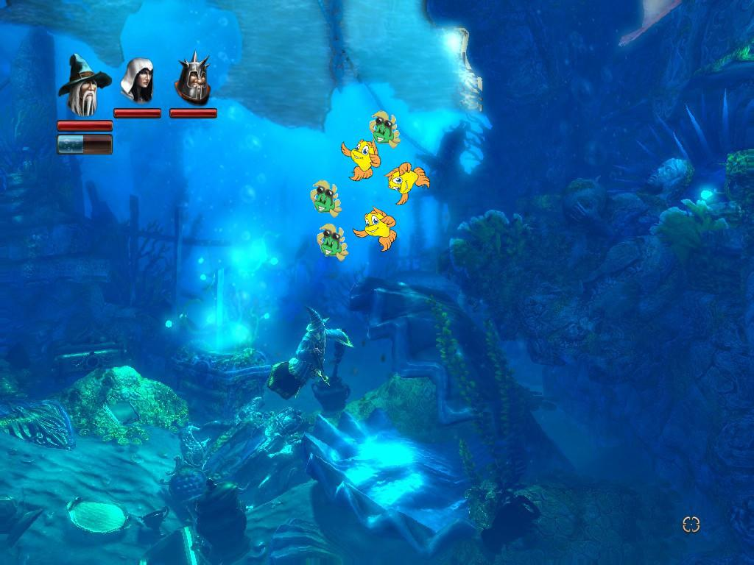

Adding more enemies to create a more difficult experience. Note that the only character that can attack underwater is the warrior type. The warrior can not swim underwater, but he can jump very high (underwater).

The fishes in the water make sure that the warrior is required for progression. This character was previously the least usable one, and by this we think we better balanced the characters. It also makes swimming underwater more fun, because you will be kept challenged. Previously, it was merely exploring to find a hidden passage and hoping you would not die. However, there was an item later in the game that let one character breathe underwater.

**Change in attributes:**

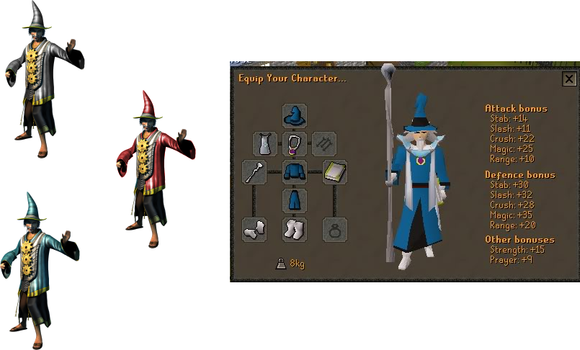

Limited slots to equip weapons and armor, with different attack and defence bonuses. Too heavy armor slows you down. Different clothes or armor pieces have different colors, and better ones look better.

**Change in internal relationships:**

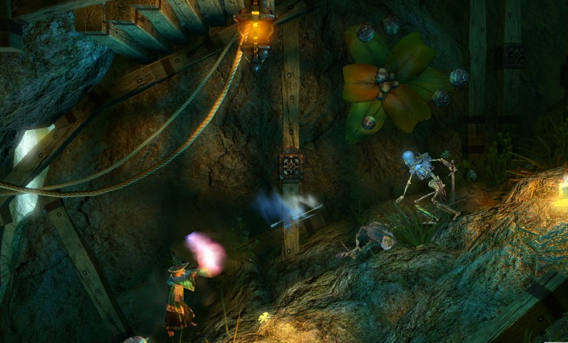

Here the wizard is able to control arrows the rogue shoots. This makes the wizard better at combat. This was a good improvement, since the wizard could hardly do anything in combat. This makes the combat more fun when you are a wizard.

**Change in environment:**

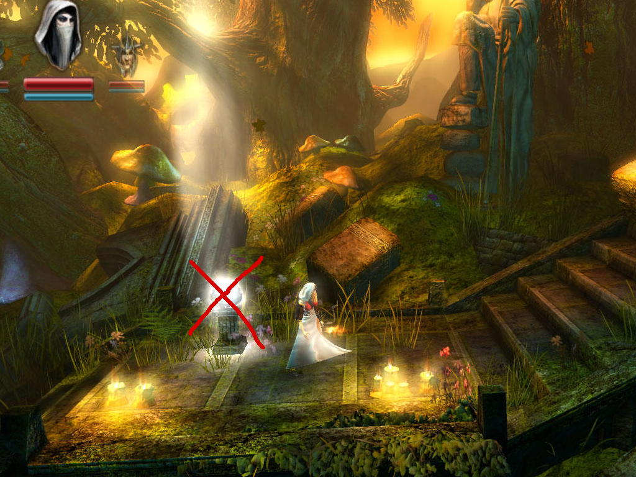

Removing a few of the checkpoints in order to make the game more punishing if you screw up - this makes it more difficult and creates a challenge for the player which should keep him more interested in playing, as long as we don’t make it too frustrating - the checkpoints do need to be in logical places.

**13. Evaluate the changes. How do they improve the experience?**

These changes add difficulty, add customization, improve combat and make certain characters more useful. This improves the experience since the game was too easy and the warrior was underused and the wizard wasn’t fun at all in combat.